ASSIGNMENT 1
NAME:Ponnisri A
CLASS:1 Msc cs
REG NO:1P25CS011

- Find the total and the average sales (display total_sales and avg_sales)

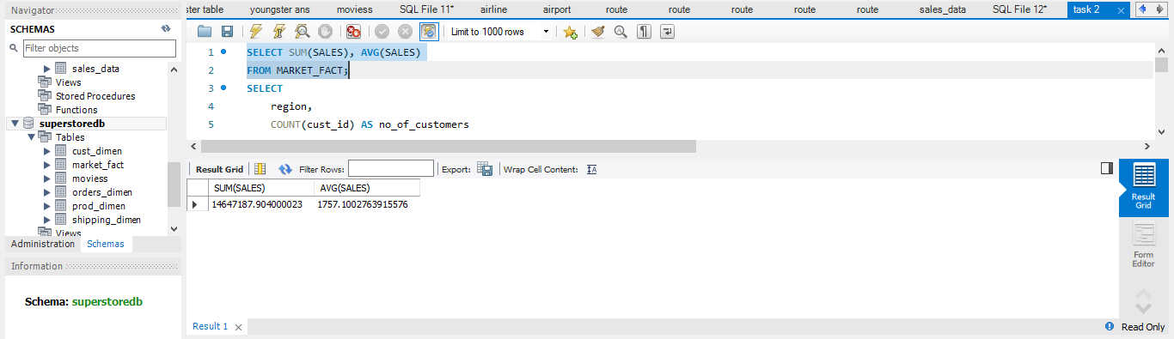

B. Display the number of customers in each region in decreasing order of
no_of_customers. The result should contain columns Region, no_of_customers

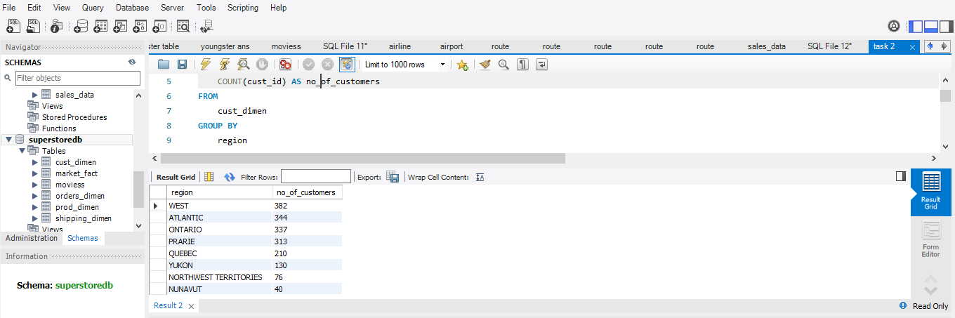
C. Find the region having maximum customers (display the region name and
max(no_of_customers)
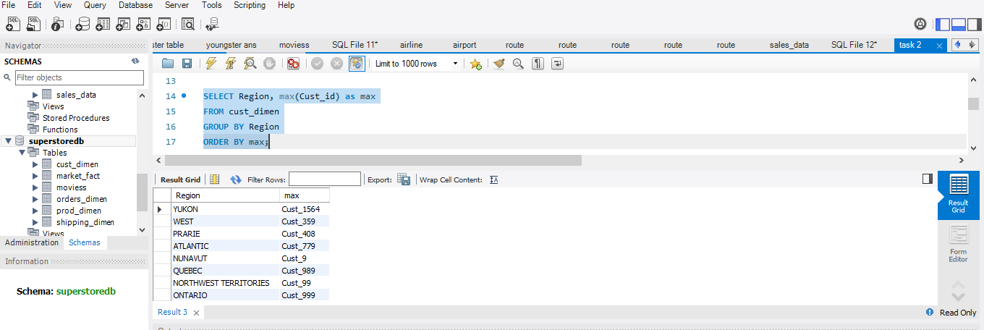

D. Find the number and id of products sold in decreasing order of products sold
(display product id, no_of_products sold).

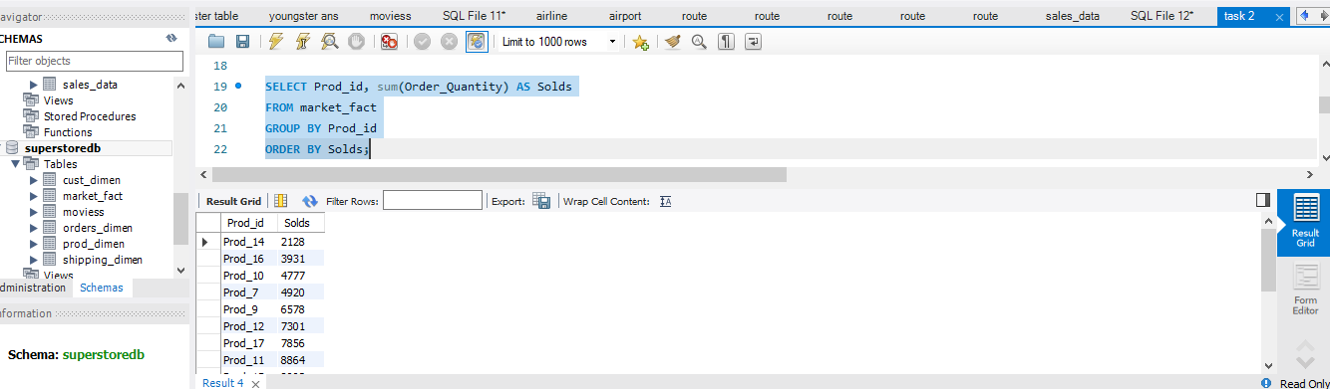
E. Display the product categories in descending order of profits (display the product
category wise profits i.e. product_category, profits)?

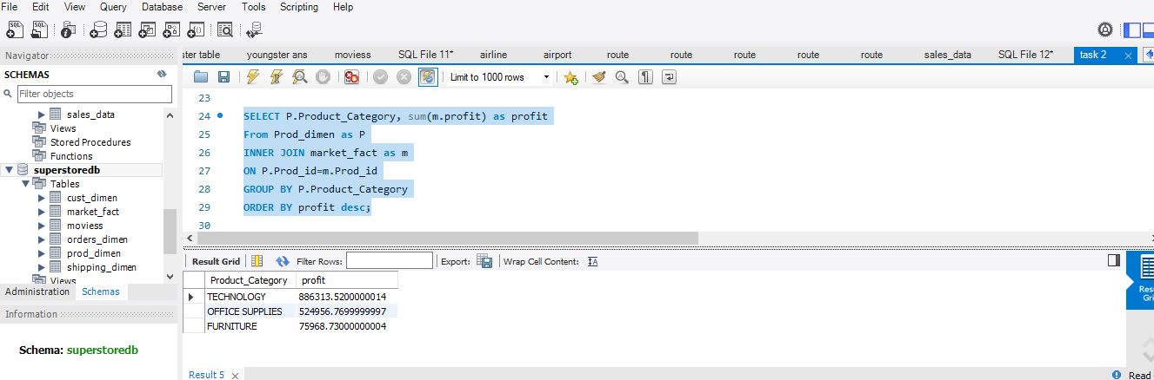
F. Display the product category, product sub-category and the profit within each sub-
category in three columns.

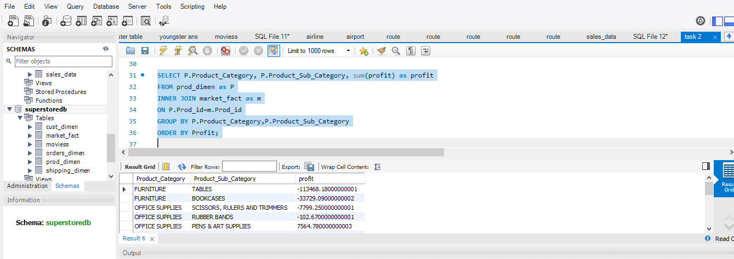

G. Find all the customers from Atlantic region who have ever purchased ‘TABLES’
and the number of tables purchased (display the customer name, no_of_tables
purchased)

